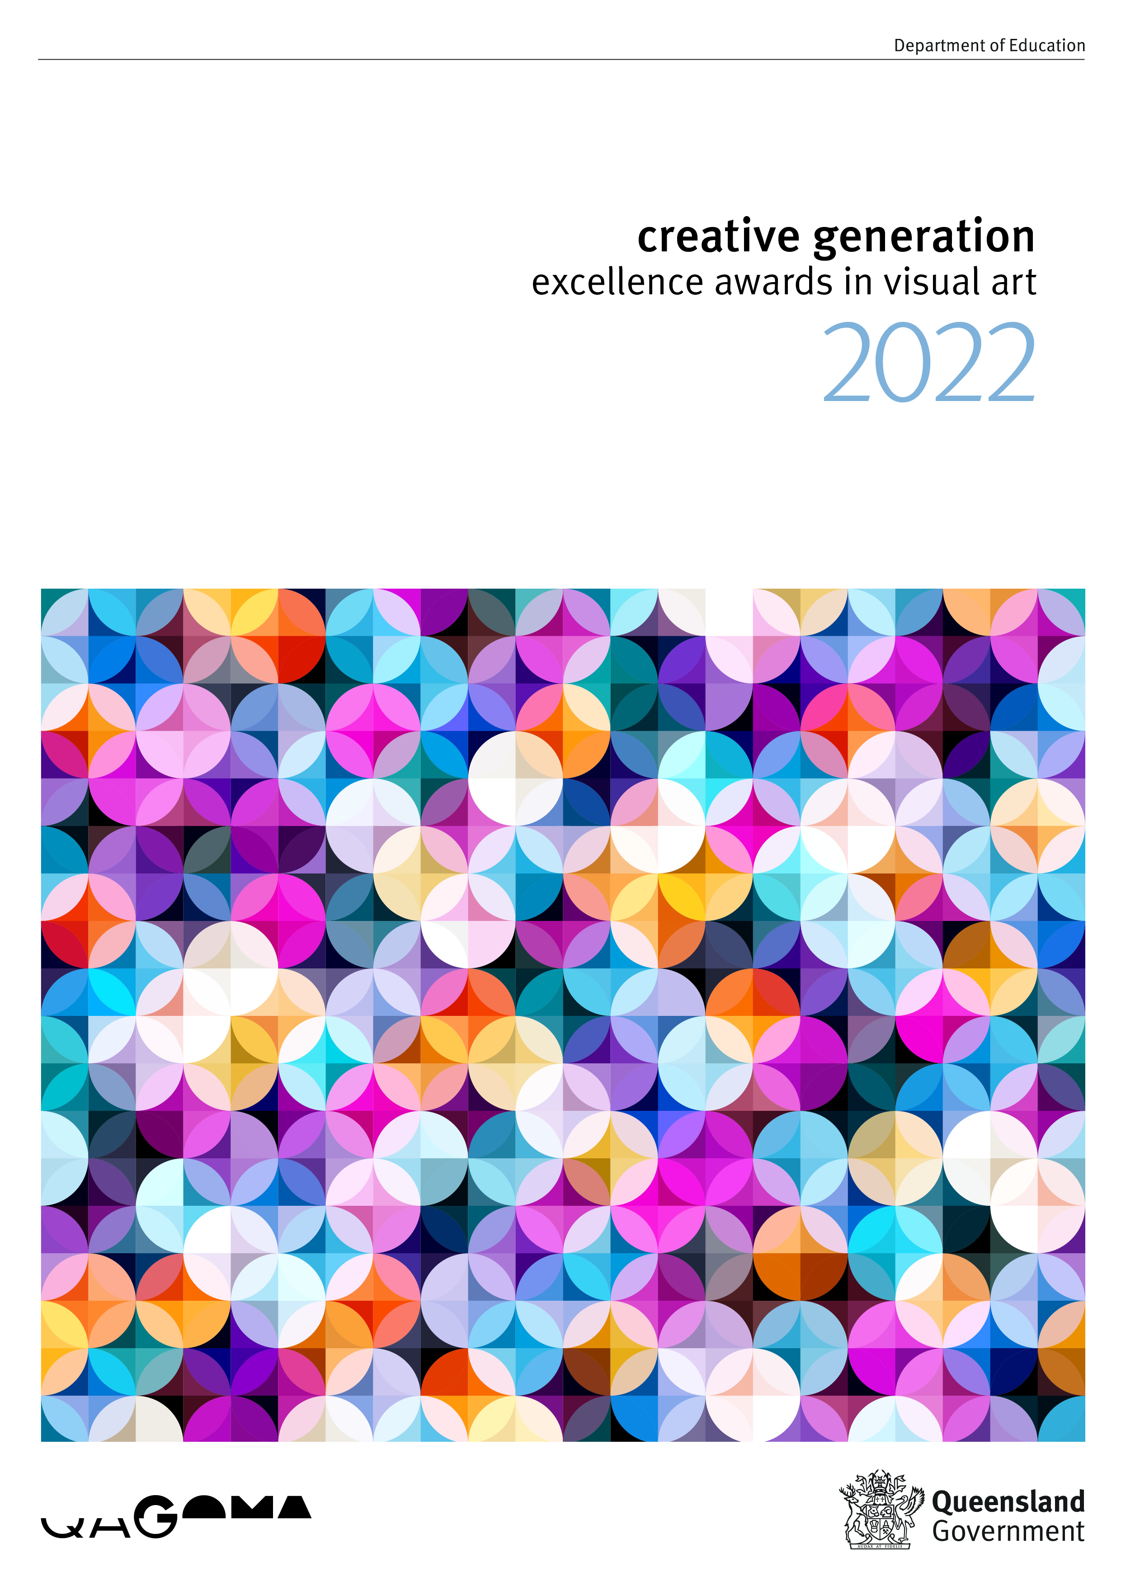
1
Information for Schools

Contents

1. About the program 2

2. Key dates 2

3. Eligibility and submission requirements 3
3.1 Submission requirements 3
3.2 Selection criteria 3
3.3 School guidelines for selecting artworks for submission 3
3.4 Copyright permissions 4

4. Submission of artwork 5
4.1 Information required upon submission 5
4.2 Uploading images and video/audio works 6
4.3 Artwork details 7
4.4 Supporting artist statement 8
4.5 Communication to schools 8

5. Judging process 9

6. Regional exhibitions 9
6.1 Exhibiting at regional exhibitions 9
6.2 Official presentation event 10
6.3 Certificates 10

7. Online gallery 10

8. Central exhibition 10

9. Insurance 11

10. COVID-19 vaccination status and implications 11

11. Terms and conditions 11

12. Contact 12

- About the program

The Creative Generation Excellence Awards in Visual Art (the awards) promote and recognise excellence in senior visual art education and student achievement in visual art throughout Queensland’s state and non-state schools.

Since 1990, the program has helped raise community awareness of the degree of sophistication in concepts, diversity of technical competence, and the high standard of visual art education in Queensland secondary schools.

The program comprises:
- the submission of 3 digital photographs of student artwork and supporting information
- the judging of all artworks to determine the excellence award recipients
- regional exhibitions showcasing all eligible, submitted artworks
- an online gallery of all eligible, submitted artworks
- an exhibition of excellence awarded artworks at the Gallery of Modern Art (GOMA) in Brisbane.

In recognition of the breadth of the visual arts, students working in the mediums of video, film and electronic imaging, as well as ceramics, costume and stage design, drawing, environmental design, fibre arts, graphic design, installation, painting, performance art, photography, printmaking, product design and sculpture are encouraged to apply.

The awards offer the only collective exhibition of senior student artwork from each region of Queensland. It is an initiative that has led to widespread recognition of the excellent work senior visual art students are producing, as well as enabling students and teachers throughout the state to share and appreciate the diversity of artwork produced in Queensland secondary schools.

This program is proudly delivered in partnership with Queensland Art Gallery | Gallery of Modern Art (QAGOMA).

- Key dates

Date | Activity
Tuesday 19 April 2022 | Submissions open for the 2022 awards program
Wednesday 31 August 2022 | Submissions close for the 2022 awards program
Thursday 8 and Friday 9 September 2022 | Judging by the state selection panel in Brisbane
September to November 2022 | Regional exhibitions and awards presentations
November 2022 | Excellence winners announced via Visual Arts Awards website and online regional exhibitions launched  (after all regional presentation events have been held)
Early/Mid 2023 | 2023 Central Exhibition at GOMA featuring the 2022 excellence awarded works

Regional exhibition dates will be available on the awards website once confirmed.

3. Eligibility and submission requirements

All Queensland state and non-state schools offering senior visual art are invited to submit up to 4 students’ artworks into the awards.

It is a requirement of the program that the school’s visual art head of department and the principal of the school where the student is enrolled, endorse the artwork as appropriate and ensure that it is compliant with the eligibility and submission requirements.

3.1 Submission requirements

For an artwork to be deemed eligible in the awards, the following submission requirements must be met.

- At time of submitting, the student must be in either Year 11 or 12 at a Queensland state or non-state school. The work must be part of their senior visual art curriculum studies in 2022 and display ready.

- Only one work per student may be submitted and up to 4 entries per school.

- Work submitted must be the work of an individual student, not the combined efforts of a group of students.

- Works must comply with the size restrictions:
- 2D = maximum of 180 cm wide x 200 cm high
- 3D = maximum of 180 cm wide x 200 cm high x 200 cm deep.

If a work is larger than the size stipulated above, the work will be withdrawn.

- Each component of the work should not exceed 20 kg. Works must be able to be lifted and carried by one person.

- A completed and unedited Department of Education project consent form must be submitted by each student and uploaded as part of the submission process. Without a completed and unedited project consent form, submissions cannot be completed.

3.2 Selection criteria

Submitted works must show an excellent standard of work that demonstrates:
- highly developed imagery and/or iconography with effective and deliberate communication of meaning
- expressive and/or innovative aesthetic choices through the control of visual language
- purposeful and considered manipulation and exploitation of media, techniques and processes
- application of knowledge and critical understanding of media, techniques and processes that allows a thorough degree of visual and expressive resolution
- a sustained engagement, which invites further inquiry from the onlooker.

3.3 School guidelines for selecting artworks for submission

Visual art heads of department and principals should consider the following questions before submitting artworks:

- Does the work portray our school and ethos for arts education in a way we wish our school to be viewed?

The principal of the school should be confident the works are deemed appropriate for a schooling initiative.

- Is this work suitable for public viewing?

Works must not contain material that may offend others by means of offensive language, images, symbols or otherwise, or are considered to infringe the intellectual property rights, moral rights or any other rights of any third party. Works must be deemed appropriate for viewing by all ages.

- Does the work contain hazardous materials?

Works must not contain materials that are unsuitable for a gallery and/or confined spaces. This includes hazardous or decomposing materials, flammable materials, broken glass, pointy/sharp edges, potting mix, untreated food and other items such as water.

- Can the artwork withstand the length of the exhibition?

All artworks must be able to withstand the length of the regional exhibition, and if selected as an excellence winner, the Central exhibition. If artworks are believed too fragile or begin to fall apart while on display, the gallery has the right to remove them from the exhibition.

- Can the work withstand transport to and from regional exhibitions?

All artworks must be able to withstand transport to and from regional exhibitions and must be exhibit-quality upon arrival. If the work receives an excellence award, the work must be able to withstand transport to and from Brisbane for the Central exhibition.

3.4 Copyright permissions

Works submitted in the awards, are viewed in public forums through an exhibition, online gallery and catalogue. As such, the program falls outside the normal scope of departmental copyright guidelines for schools.

Students must have the permission of the copyright owner of any work reproduced in their artwork to enable the works to be exhibited at their regional exhibition. This includes appropriations, for example well-known company logos. Found items such as branded products (i.e. drinks cans, cereal boxes) do not require permissions.

When using popular/commercial music in video submissions, the artist statement must disclose this, and permission to feature such music must be sought by the school. Proof of copyright permission or proof the music is copyright free must be provided to the program manager at time of submission. PLEASE NOTE, if permission is not sought or granted, video submissions will be presented to the judging panel without sound.

Students whose works are inspired by another artist or artwork, for example Indigenous symbols, must acknowledge the source or artist in the artist statement.

Audio only sound recordings
School/student should contact APRA to check who owns copyright mechres@apra.com.au.

After APRA there is a separate copyright in the sound recording of a song. Please contact ARIA (www.aria.com.au) for further information on this copyright clearance.

Copyright owners will normally ask you for specific information about how you plan to use the music. The sort of information you should have ready before contacting the copyright owner includes:
- Company/contact details
- Title and composer details of the musical work
- Artist information if applicable
- Medium (e.g. festivals, cinema, free to air television, cable, CD etc)
- Territory for which the licence is required
- Term for which the licence is required
- Duration of the music used
- Proposed usage (including product name if applicable).

Sound recordings in a video
Or known as a synchronisation licence. In order to arrange licensing for the sound recording the school/student will need to contact the copyright owner directly – this is normally a record label.

Short video clips advice

1. Using short video clips in student video – insubstantial copying

If clips are very short (under 5 seconds), it may be arguable that this would be considered an insubstantial amount for copyright purposes and is okay to use. Whether or not a clip is considered insubstantial will depend on how much is used and what is used, so it can be a tricky assessment to make. Even a very short clip can be considered substantial if it is a distinctive or important part of the film. The student would need to ensure these are properly attributed in the video (i.e. in the end credits).

2. Relying on the ‘fair dealing’ for research or study exception

If the clips were not considered to be an insubstantial amount, we believe the fair dealing for research and study exception in the Copyright Act is likely to apply. Students can rely on this exception where they incorporate other people’s material into their assignments, class activities and homework exercises. If the student originally prepared the video as part of their class activities, it is arguable that the fair dealing exception will continue to apply to the student’s work to be included in the Queensland Visual Art Awards. This is because the student originally used the copyright material for the genuine purpose of research and study and not for inclusion in a public competition.

3. Risk

Note that there is a risk that the film studios may complain about the use of the clips in the student video. The student is also being asked to warrant that they have acquired sufficient rights, and to indemnify the department against any loss or damages caused by a breach of this warranty (Terms and Conditions, clause 9). The student and/or school will need to be prepared to make arguments based on the advice above. The school should contact us for assistance if this occurs.

Schools should familiarise themselves with copyright information by visiting the Smartcopying website.

4. Submission of artwork

Submissions are only accepted online. To enter the awards, visit the awards website.

4.1 Information required upon submission

The following information is required to submit each student artwork into the awards:

- school name, address, phone number and region
- school visual art head of department name, email address and phone number
- school contact teacher name, email address and phone number
- student name and year level
- artwork title
- artwork description (20 words maximum e.g. 3 canvases or video)
- artwork medium (drop down option for schools to choose, or select other and type)
- artwork process (100 words maximum on how the student created the work)
- artwork process supporting documentation (optional maximum one A4 page)
- artist statement (100 words maximum)
- artwork weight (20 kg maximum)
- exact dimensions of installed artwork: height (200 cm maximum), width (180 cm maximum), depth (200 cm maximum)
- upload 3 photographs per artwork or one screenshot of a video work (JPG or TIFF format and maximum 5 MB per photo)
- upload video or audio file (MP4 or MOV format and maximum 300 MB per file)
- copyright information
- upload completed Department of Education project consent form.

Upon submission, schools must nominate a contact teacher and provide their contact details. This person will be the point of contact for all submissions until the program concludes and will receive the confirmation email upon success of submission. Other teachers may submit student works on behalf of the contact teacher however students are not permitted to submit entries.

To avoid last minute technical delays, it is recommended schools upload their submissions prior to the closing date.

Students involved in the awards are doing so as representatives of the Queensland school they attended when the work was completed. As such, all ongoing reference to the student’s artwork for the duration of the awards program will be made with the inclusion of that school’s full name. Once artworks are submitted only spelling errors identified by the school will be corrected. Any significant changes to details cannot be made.

4.2 Uploading images and video/audio works

Images of student artworks are required for the judging process, the online gallery and promotional material relating to the awards. Three images per submission or one screenshot per video work are required upon submitting. Schools are responsible for photographing the artwork and submitting high quality images for the judging panel's review. It is imperative to provide a clear and accurate reproduction of the original work as these images will be used for judging, online exhibitions and, if selected, as an excellence winner – for the printed catalogue and poster.

Before submitting these images please ask yourself – ‘Are these images the best representation of the submitted artwork?’ If you are worried about the upload quality or unsure about the best way to photograph the artwork please contact the program manager for assistance.

Video or audio works must be uploaded within the submission portal as either MOV or MP4 files to ensure they can be viewed on the department’s computers and laptops. The files cannot exceed 300 MB. If the video work is too large to be uploaded please attempt to reduce it. Higher resolutions can be provided for exhibition purposes.

Image size guidelines

Images must be larger than 500 KB and no bigger than 5 MB. Ideally, images will be between 2–3 MB and must be in either JPG or TIFF format. If images are not clear, they cannot be presented for judging.

Techniques to achieve the best photo

Photographers are encouraged to:
- capture the artwork only (do not take the photo with the artist, a ruler or student/school details in shot)
- if the artwork is a digital image, submit the original digital file
- place the artwork against a clean, light, single-coloured (preferably white) background
- photograph the works before framing, to avoid reflection from perspex or glass
- use the best camera available, alternatively a smartphone may be used
- if possible, use a tripod or camera support
- photograph 3D works from different angles
- ensure the image is sharply focused and fills as much of the frame as possible
- stand squarely in front of the work – photographing from an angle will distort the work
- do not use a flash
- take a number of photographs using different exposures.

The first photograph must be an overview shot, showing all pieces and elements of the artwork as it would look on display.

First photo example:
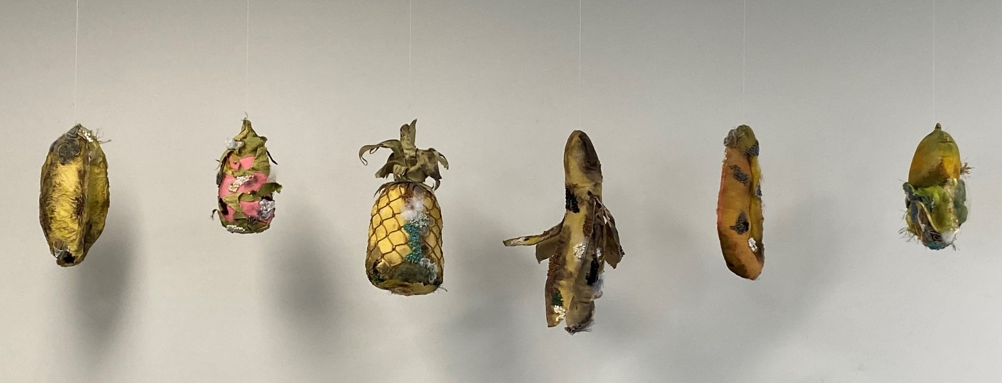

The second and third shots are to be detailed photographs of selected sections of the artwork. Please keep in mind it is hard for judges to assess a work if they can’t view its entirety and its detail.

Second and third photo example:
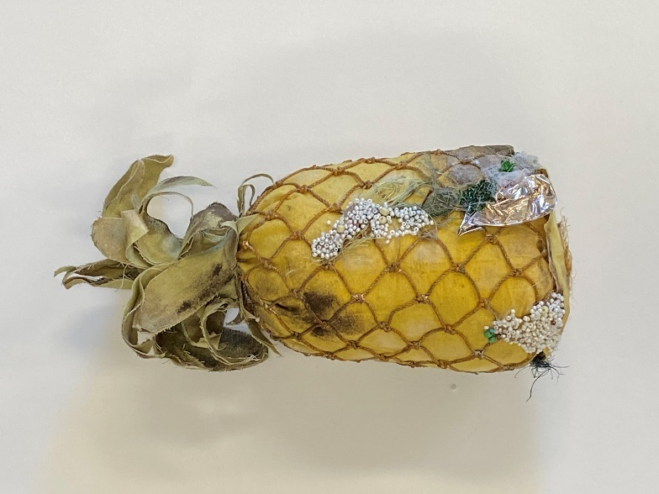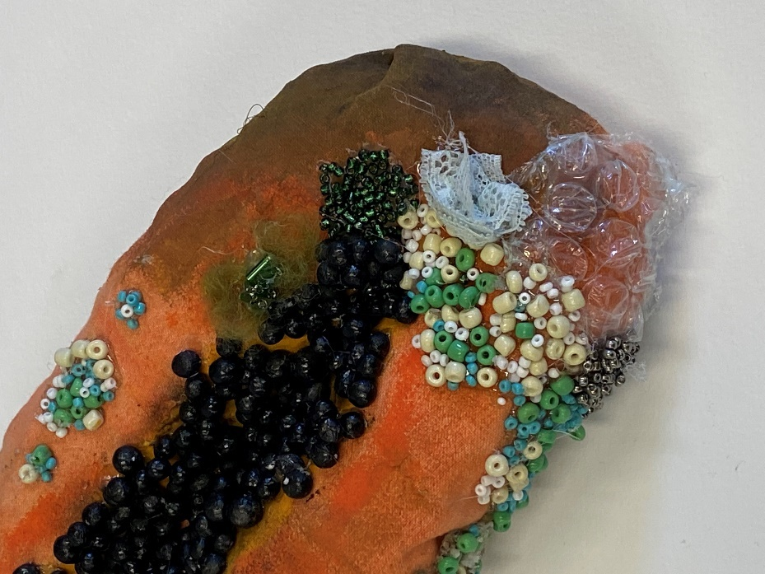
Images: 2021 Excellence winner, Holly McDougall, St Margaret Mary's College (Hyde Park)

4.3 Artwork details

The following artwork details will be used during the judging process. It is important that these details are as accurate as possible:

Artwork description (20 words maximum)
A physical description of the artwork and the number of components that are to be judged; i.e. 3 canvases, video projection onto canvas, sculpture or digital media installation. Materials used to create the artwork; i.e. acrylic on canvas, graphite on wax paper or fabric sculpture. For digital works, describe the video duration, colour and sound.

Artwork medium (20 words maximum)
Type of artwork: painting, drawing, print, photograph, video, film/electronic imaging, installation, sculpture, costume design. If choosing other, please specify.

Artwork process (100 words maximum)
Explain the processes the student employed to create the artwork. Include as much detail as possible, particularly any new and innovative techniques to explain the work involved to reach the final product.

Artwork process supporting documentation (optional maximum one A4 page in JPG, PDF or Word format)
To support the student’s submission, the process of how they designed/developed their work would be recommended to enhance the story of their work for the judging panel. Supporting documentation could include images and annotations from their visual art diary, explanation of their concept development, samples of experimentation with materials and techniques, and creative influences.

Artwork weight (20 kg maximum) and Artwork dimensions (height 200 cm maximum, width 180 cm maximum, depth 200 cm maximum)
Provide exact measurements of the artwork as if hung, projected or staged. This is important as these measurements are used by the GOMA following judging. Submissions exceeding the maximum allowances cannot be accepted.

4.4 Supporting artist statement

Each submission must be accompanied by a supporting artist statement, no longer than 100 words. The artist statement must be written by the student, be grammatically correct and be approved by the school. The artist statement will not be proofread by the program manager prior to being presented to judges, to avoid any misrepresentation.

The statement should explain why the student produced the work, their ideas and what the work represents. The artwork process should explain how the work was produced and what skills and techniques were used. Please note that artist statements will be displayed with works, artwork process is for the judging information only.

Reproduction of any elements of other artists’ works must be referred to in the artist statement. Please refer to section 3.4 Copyright permissions for more information.

For excellence award recipients, the student's name and school, artwork title, medium, artist statement, artist process and supporting documentation may feature in the Central Exhibition catalogue, interactive screen within the exhibition, and be published on QAGOMA’s website to support the central exhibition. Original images/files may be sought by the department or QAGOMA if required for the in-gallery interactive screen or QAGOMA website.

The Department of Education will proof the artist statements to ensure they align with departmental and gallery standards and guidelines. The department will provide each student with their artist statement for approval prior to final release to QAGOMA.

In some cases, associated gallery curators, representatives or advisors will also be required to approve an artist statement in collaboration with the program manager. Final approval of each artist statement rests with the program manager, who will take into consideration the feedback from all invested parties.

4.5 Communication to schools

The school contact person nominated in the submission process will be used by the program manager and the regional coordinator to communicate important information.

Examples of communication may include, but are not limited to:
- notification of ineligible works
- request for further information or completion of forms
- looming deadlines, milestones and/or key activities
- organisation of the regional exhibition
- award information and/or notices
- regional or central exhibition invitations.

It is the responsibility of the school contact teacher to inform the principal, and relevant teachers and students of all key milestones and activities related to the awards for the duration of the program, as they are the sole contact.

5. Judging process

The program manager will present only eligible submissions to the judging panel. Student names and schools will not be disclosed to the judges.

The selection panel will convene in September 2022 and will shortlist up to 150 works from all submissions received.

Following the shortlisting process, the panel will:
- select up to 40 excellence award recipients from the 150 shortlisted works
- select one student from each region as the regional encouragement award recipient.

The panel is made up of expert panellists, recognised by the department as outstanding practitioners, administrators and advocates of visual arts. The judging process is rigorous and final. No communication will be entered into to seek feedback or justification of outcomes finalised by judges. There is no requirement for judges to allocate the full quota of awards.

6. Regional exhibitions

All students who submit eligible works are invited to exhibit their artwork at exhibitions in their region throughout September to November 2022. The regional exhibitions are a great opportunity to showcase students’ talents, to celebrate student achievements with friends, family and peers, and to announce students who have been selected as award recipients.

Each region has a regional coordinator, whose details will be listed on the program website, who manages the exhibitions in conjunction with the exhibiting gallery. Regions may conduct more than one regional exhibition if they secure additional funding. Regional coordinators will provide teachers with regional updates via the website and email. Please ensure you contact the regional coordinator if you have any questions or queries about the program.

6.1 Exhibiting at regional exhibitions

Regional coordinators manage the regional elements of the program and therefore it is best to contact your coordinator regarding the regional exhibition.

Due to the overwhelming number of submissions the program receives, it is likely that larger regions will have to limit the size of an exhibition due to venue restrictions. This could include limiting the number of artworks exhibited per school, or limiting the number of elements exhibited per student (for more complex artworks). Please consult with the program manger should you have any questions or queries.

It is the responsibility of each participating student and their teacher to organise, pay for and manage the transportation of works to the regional exhibition. The department is unable to provide funds to support this element of the program. Students should consider the method of transport and the appropriateness of this transport given the fragility of the works. The department cannot be held liable for any loss or damage caused during this process.

For works that require particular arrangements or configurations, a photograph or detailed diagram must be provided to the regional coordinator with the artwork to ensure works are installed correctly. Works submitted must be prepared for hanging, complete with frames and hanging devices. If the artwork is not equipped with appropriate hanging devices it cannot be hung. Schools must be prepared to provide items such as a laptop or monitor for video works, or a plinth, in the instance that galleries are unable to provide these items.

All works requiring power must be tested and tagged by a licensed electrician, prior to exhibiting at the regional exhibition. Proof of test and tag may be requested.

To exhibit, all eligibility and submission requirements must be adhered to, including meeting deadlines requested by the program manager or regional coordinator. Please be aware that regional galleries may advise of their own exhibition requirements, in addition to the program’s, to adhere to their exhibition or health and safety guidelines.

6.2 Official presentation event

Students, their families and school representatives will be invited to attend an awards ceremony or official opening of the regional exhibition where the announcement of awardees will take place.

Regional coordinators will communicate exhibition dates and details, delivery specifics and exhibition requirements to the visual art head of department and/or contact teacher via the website and email.

6.3 Certificates

At the regional exhibition award ceremony, students will be presented with certificates of excellence, commendation, and regional encouragement.
- Certificates of Commendation will be presented to up to 150 students whose works were shortlisted.
- Certificates of Excellence will be presented to up to 40 excellence award recipients.
- Certificates of Regional Encouragement will be presented to one student per region (7 in total)
- Certificates of Participation will be provided as a PDF and emailed direct to the contact teacher.

7. Online gallery

The online gallery will complement the regional exhibitions and displays all eligible works submitted into the awards. The online gallery will be accessible to the general public via the awards website from November 2022. It is an excellent opportunity to view the outstanding artworks created by senior visual art students across Queensland.

8. Central exhibition

The 2022 excellence award winning works will be exhibited at GOMA in Brisbane in 2023.

The central exhibition is the pinnacle of the program where excellence awarded students, their families and school representatives are invited to attend the official opening of the exhibition. GOMA provides a world class facility in which to view the student exhibition, offering a once in a life time opportunity for many aspiring artists.

It is important to note, if your student is a 2022 excellence recipient, the school is required to hold onto the artwork for collection by a professional art transportation company in early 2023.

In preparation for GOMA, school/student responsibilities are to:
- attach hanging fixtures to the back of the works prior to arriving at the gallery
- label the artwork (out of sight) and packaging with the student's name and school so the gallery can easily identify it
- complete the GOMA form provided by the department, including clear installation instructions and/or diagrams of sequence for installation
- ensure winning works requiring power are tested and tagged by a licensed electrician prior to collection
- package the work appropriately for long distance travel. A consideration may be to purchase insurance. The department cannot be held liable for any loss or damages caused by inappropriate packaging
- ensure the artwork is available for collection from the school early 2023. If required students/schools must organise, pay for and manage the transportation of their work to the school collection point. Students should consider the method of transport and the appropriateness of this transport given the fragility of the works.

The department's responsibilities are to:
- organise and pay to transport the works from the school to Brisbane for the central exhibition
- cover the cost to deliver works back to schools once the central exhibition has ended. The department and the gallery will work together to re-package works to withstand the trip home.

Please note that GOMA cannot be expected to accommodate presentation requirements that fall outside their standard parameters, for example one-of-a-kind plinths or light boxes. These items must be provided by the exhibiting artist. These types of presentation requirements are deemed part of the work and therefore must adhere to the size restrictions. The central exhibition is a group show and the installed dimensions of an artwork must adhere to the size restrictions. GOMA will endeavour to keep the works protected from loss and damage whilst in their care.

9. Insurance

Queensland Government Insurance Fund can only insure the department whilst the works are in the care, custody or control of the department and the legal liability of the department subject to policy terms and conditions.

The department cannot be held liable for any loss or damage caused in times of transport, exhibition or storage as they relate to the program. Students should therefore consider taking out insurance for their works, particularly as throughout the program, works may be in the care, custody or control of other parties or contractors and therefore at risk.

10. COVID-19 vaccination status and implications

From 17 December 2021, restrictions have been put in place for unvaccinated people aged 16 years and over. These restrictions include being unable to attend some indoor entertainment venues and Queensland Government owned galleries such as Queensland Art Gallery | Gallery of Modern Art and possibly regional exhibition venues. Creative Generation Excellence Awards in Visual Art will be operating in accordance with all Queensland Health mandates, and will advise if any further changes to these restrictions are made.

It is a requirement of all program participants to ensure they are compliant with relevant mandates and are aware that the program may be affected by unforeseen circumstances impacting the intended delivery of regional exhibitions and the central exhibition in particular. Please contact the regional coordinator for your area, or the program manager if you have any questions.

11. Terms and conditions

In these terms and conditions 'the department' means the State of Queensland acting through the Department of Education.

- Information on how to enter and participate in the Creative Generation Excellence Awards in Visual Art, including all program guidelines, information books, forms and fact sheets, form part of these terms and conditions of entry. Participation in the program will be considered acceptance of these terms and conditions.
- The department (ABN 76 337 613 647) is the owner of the Creative Generation Excellence Awards in Visual Art program.
- Once entered, details are not transferable to any other person or organisation or school.
- Late, partially completed or submissions that do not satisfy the submission requirements or program guidelines at the time of the program entry closing may be judged as ineligible for participation in the program.
- All information submitted must be true and correct as at the time of submission.
- The decision made by the department to accept a student as eligible to proceed to the next stage of the program is final and no correspondence will be entered into.
- The department accepts no responsibility for inability or failure to submit or nominate by the final date.
- The nominee grants the department the right to use personal information (including student details, photographs and/or video) in accordance with the project consent form.
- By providing material (including student details, photographs and/or video) to the entry portal, the nominee warrants they either own the material or have acquired sufficient right to use the material for the purpose of the program, and agree to indemnify the department against any loss or damages caused by breach of this warranty.
- Where there is more than one category or stage, each category or stage may have individual eligibility criteria as well as judging criteria.
- Although every effort will be made to ensure project materials (including certificates, prizes and awards) are sent to the address stated on the submission, the department takes no responsibility for lost or misdirected items not received by students/schools.
- The department will not be responsible for any problems or technical malfunction of any network or lines, servers, providers, computer equipment, software, traffic congestion on the Internet, etc. including, but not limited to, any injury or damage to participants or any other person's computer related to or resulting from participation, or downloading any materials, in this program.
- If for any reason the program is unable to run as planned, including causes beyond the control of the department, the department may at its sole discretion cancel, suspend or modify the program.
- The department will not be responsible for any failure by sponsors and partners to fulfil obligations.
- The program may be withdrawn at any time without notice.
- The participant agrees to indemnify the department against any loss or damages caused by a cancellation, suspension, modification or withdrawal of the program.
- These terms and conditions may be altered where necessary, and any changes will be notified on the program's website.
- The department reserves the right, at any time, to verify the validity of a submission, reject a submission or disqualify a submission that is not in accordance with these terms and conditions.
- After reading and understanding all elements of the Information for schools booklet, it is understood by the department that schools and students proceeding with submission, agree to, and will adhere to, all elements of the program.

12. Contact

For further information, please contact the program manager on (07) 3328 6619 or at artawards@qed.qld.gov.au.

At the time of printing, all information in this document is correct. If amendments to the program are made in any way, the website will be updated in the first instance. All necessary updates will also be communicated to the school contact teacher via the regional coordinators at the earliest possible convenience.

